API Documentation: Project Dalupotha
Base URL: https://api.dalupotha.factory.local/v1 Content-Type: application/json Authentication: Bearer Token (JWT)
1. Global Error Codes
The Dalupotha API uses standard HTTP status codes to indicate the success or failure of an API request.
HTTP Status Code | Description | Example Scenario
200 OK | Success | Request was processed successfully.
201 Created | Created | A new resource (e.g., user, collection record) was created.
400 Bad Request | Validation Error | Missing required fields, invalid GPS coordinates.
401 Unauthorized | Auth Failure | Missing or invalid JWT token, invalid OTP.
403 Forbidden | Access Denied | User lacks the required role (e.g., TA trying to approve a machine rent).
404 Not Found | Resource Missing | Requested Supplier ID or Item ID does not exist.
409 Conflict | Data Conflict | Duplicate passbook number or contact number during registration.
500 Internal Error | Server Failure | Database connection failure or unhandled exception.

Standard Error Response Format:
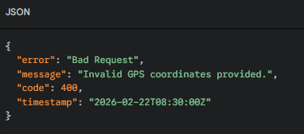
2. Authentication & Registration Endpoints
2.1 Staff & Transport Agent Login
Authenticates internal users and returns a JWT for subsequent requests.
- Endpoint: POST /auth/login
- Access: Public
Request Body:
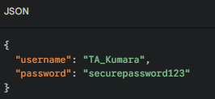
Response (200 OK):
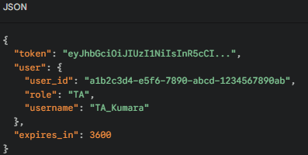
2.2 Small Holder Registration (OTP Flow)
Registers a new Small Holder with GPS mapping.
- Endpoint: POST /auth/small-holder/register
- Access: Public
Request Body:
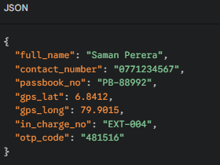
Response (201 Created):
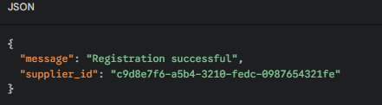

3. Field Collection & Logistics Endpoints
3.1 Sync Leaf Collections (Transport Agent)
Used by the Transport Agent mobile app to sync offline-captured green leaf data to the central database. Supports batch uploading.
- Endpoint: POST /collection/sync
- Access: Requires TA Role
Request Body:
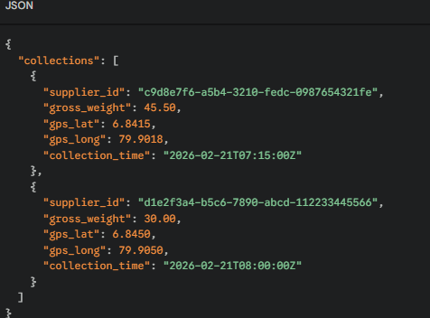

Response (201 Created):
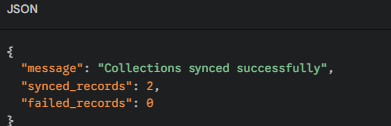
3.2 Get Leaf Supply History
Retrieves the brought leaf history for a specific supplier.
- Endpoint: GET /collection/history/{supplierId}
- Access: Requires SMALL_HOLDER, EXT, MG, or TA Role
- Query Parameters: ?startDate=2026-02-01&endDate=2026-02-21
Response (200 OK):
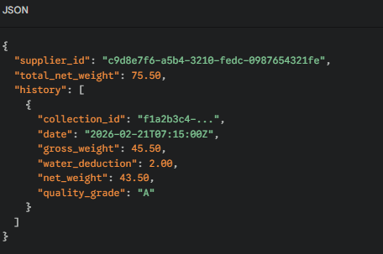
4. Financial Ledger Endpoints
4.1 Request Financial Advance
Allows a Small Holder (or a TA on their behalf) to request an advance payment.
- Endpoint: POST /finance/advance-request
- Access: Requires SMALL_HOLDER or TA Role
Request Body:
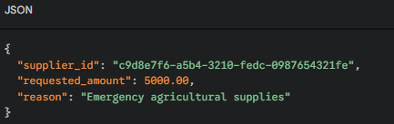
Response (201 Created):
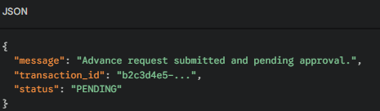
4.2 Get Financial Ledger Details
Fetches the current financial standing (debts, advances, payouts) of a Small Holder.
- Endpoint: GET /finance/ledger/{supplierId}
- Access: Requires SMALL_HOLDER, EXT, MG, or SK Role
Response (200 OK):
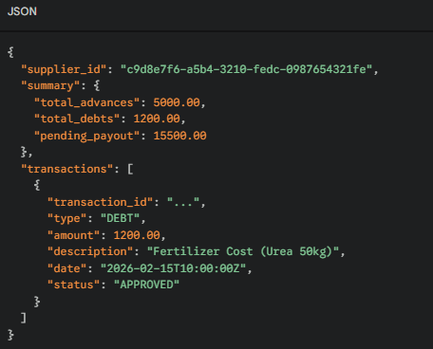
5. Service & Inventory Endpoints
5.1 Create Service Request
Submit a request for fertilizer, machinery, or transport.
- Endpoint: POST /services/request
- Access: Requires SMALL_HOLDER or TA Role
Request Body:
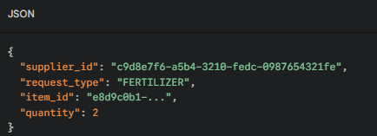
Response (201 Created):
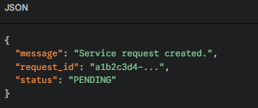
5.2 Update Service Request Status (Approval)
Used by Management or Store Keepers to approve/dispatch requested items.
- Endpoint: PATCH /services/request/{requestId}/status
- Access: Requires MG, EXT, or SK Role
Request Body:
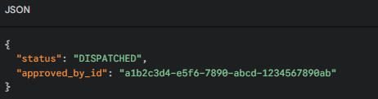
Response (200 OK):
